**Agile Delivery Services BPA**

**RFQ ID: RFQ993471**

**Pool 1**

**Evidence Item:** J

**Installation Instructions**

1. **Download code/files from GitHub.**

* In your web browser, navigate to this URL: github.com/INCATech/GSA-Agile-Design
* Click “Download ZIP” button on bottom right corner of screen:

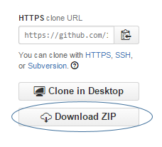

1. **Transfer code package (Step #1) to new machine.**
2. **Unzip code package on new machine.**

* The code/files will need to be placed in the proper location on the new machine. To be accessible from web browsers external to the new machine, the code/files must be place in the web server root directory, or any child folder of the root directory.

1. **Access prototype via web browser by using your new machine URL, with additional folder names in URL if files were placed in child folder of Root, and accessing index.html.**